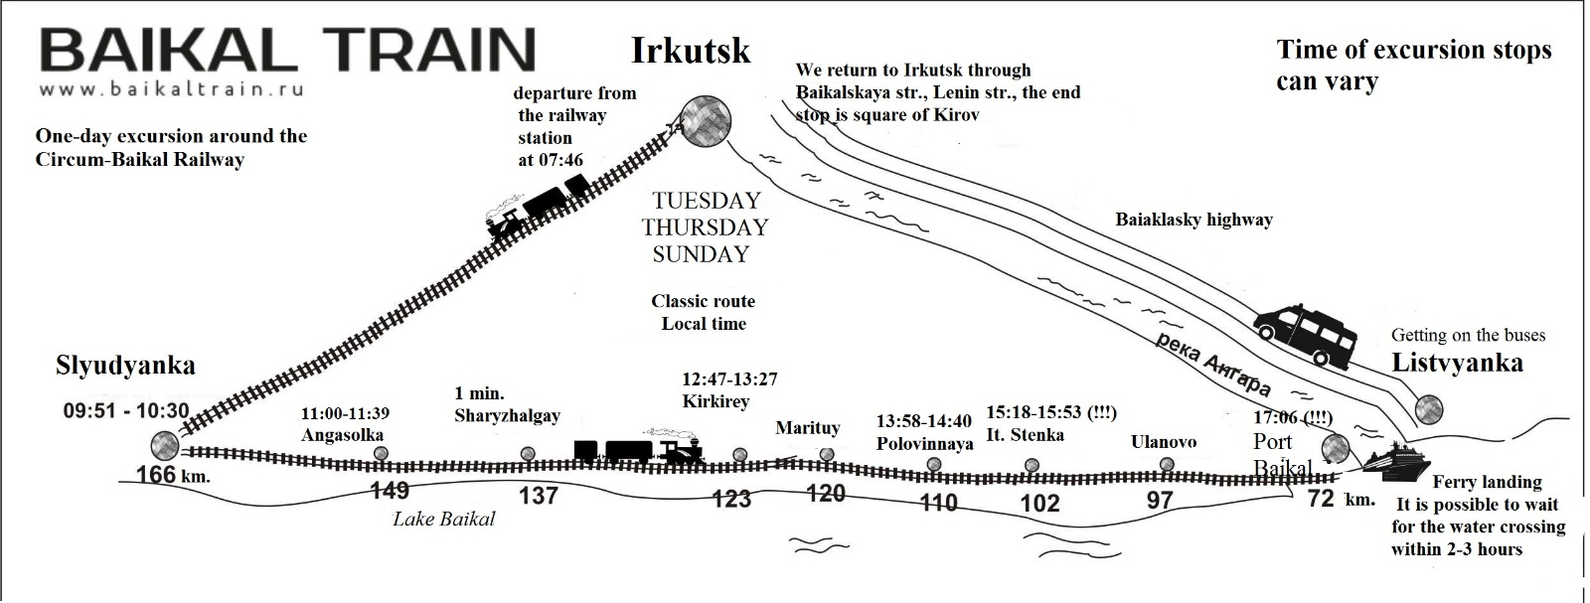

Irkutsk-Passazhirskiy | 07:46
Slyudyanka (166 km) | 09:51-10:30
Angasolka (149 km) | 11:00-11:39
Sharyzhalgay (157 km) | 12:11-12:12
Kirkirey (125 km) | 12:47-13:27
Polovinnaya (110 km)  Departure at 14:36 for shortened programmes | 13:58-14:40
Italyanskaya Stenka (The Italian Wall) (102 km)  No stop for shortened programmes | 15:18-15:53
Port Baikal (72 km)  Departure at 16:08 for shortened programmes | 17:03
On Tuesdays, Thursdays, and Sundays, the tour train departs from the railway station at 07:46 local time. The boarding begins 15 minutes before departure. The train number and the path number will be displayed on the information board above the exit to the aprons. The boarding will be independent based on tickets that need to be prepared in advance and shown to the train attendant. The tickets will be checked again in the cars immediately after the train departs. After the tickets have been checked, breakfast will be served *.
Heading from Irkutsk to Slyudyanka, the train goes east. There will be no stops except for a one-minute stop at Goncharovo station (Shelekhov) at 08:05.
In Slyudyanka, a stop lasts approximately half an hour. You can get out of the car and enjoy the station building – the only railway station in the world that is completely built of white and pink marble.
At 10:30, the train departs from Slyudyanka in a western direction to the Circum-Baikal Railway.
The first tour stop is Angasolka (39 minutes).
As you get out of the train please walk in the opposite direction, to the tail of the train. The guide will wait for you there to begin the guided walk.
Next stop is Sharyzhalgay (1 minute). This is a technical stop. Please make sure you stay in your car. Immediately after this stop, lunch is served for those who have ordered the service.
Next tour stop is called Kirkirey (40 minutes). You can go out from cars No. 1, No. 2, No. 3, No. 4 only. Therefore, for those who travel in cars Nos. 5, 6 and 7, it is necessary to proceed to the said cars to join a guided walk. Please be careful! Make sure to not walk too far away from the train. Listen carefully to the locomotive signals – the train leaves after the third signal.
Next station is Polovinnaya (42 minutes). This is a free time stop. There will be no guided walks. At this stop, meals are served for those who have ordered the Homemade Lunch (Domashny Obed) service. Make sure to ask your guide at the beginning of the journey where you will eat. There are two options: 1) we will accompany you to the veranda, where the lunch is served; or 2) we will bring the lunch to your car. The stop may be longer. Please listen carefully to your guide.
There is a small settlement called Polovinny in the area and Polovinnaya River flows there as well – it is the largest river in the western part of the Circum-Baikal Railway. It is 43 km long. Above the river, there are two bridges:
- A metal bridge built during the first stage of the railway construction with train ways down and the 6 m wide opening. Its weight is 203.2 tons.
- A reinforced concrete viaduct of arch type built during the second stage of the railway construction with three openings of 20 m each. It is 84 m long.
Before the bridges, you will see an old E Series steam locomotive. Locomotives of that type used to be delivered to Russia from the US in 1943-1944 under the Land Lease Supply Program during the World War II. The locomotives were also called Amerikanka trains. The capacity of the locomotive is 1,920 hp, speed – 70 km/h, length – 21 m, and weight – 103 tons.
There also is a very convenient descent to Baikal to a cozy shallow-water bay, located between the Polovinny Cape and the small but very steep Chaykin Cliff.
There, too, is the longest tunnel of the Circum-Baikal Railway, the tunnel No. 12, or Polovinny Tunnel. Its length is 778 m. Besides, this tunnel is completely straight; if you stand at one end of it, you will see the light coming from the other end. In the same area, you can find the shortest tunnel (32 m), which, according to legend, makes the most cherished wishes come true.

ATTENTION! The route may be shortened for an hour because of the train No. 924 that will go along the same railway. Please ask the train attendant to provide the precise details.
Next stop is Italyanskaya Stenka, or The Italian Wall (35 minutes). This is a sightseeing stop (if you have a shortened programme, the train will not stop here).
The Baikal station is the terminus of the Circum-Baikal Railway route. Do not forget your belongings in the car. In the Port Baikal, you will board the ship; during the boarding, your coloured bracelets will be checked. Each person will wear a bracelet during the tour, the colour of which corresponds to a certain ferry queue. There may be two to three hours of waiting for your turn to board the ferry.
If you have to wait for your ferry, feel free to visit the Port Baikal museum of the Circum-Baikal Railway construction history that is located in the station building (the entrance to the museum is free), drink some coffee in the canteen, have a walk along the picturesque terrain, and take photos with an old locomotive on the background.
Right after the ferry arrives to Listvyanka, the boarding to buses begins on the pier. Then you will be transferred to Irkutsk along the Baikalsky Tract. The bus will not stop for museums and the fish market in Listvyanka.
In Irkutsk, buses go along Baikalskaya Street and Lenina Street. The final stop is Kirov Square (Hotel Angara). Provided that you have warned the driver in advance, you may get off the bus at any stop of this route.
Please do not leave your belongings in the car unattended.

