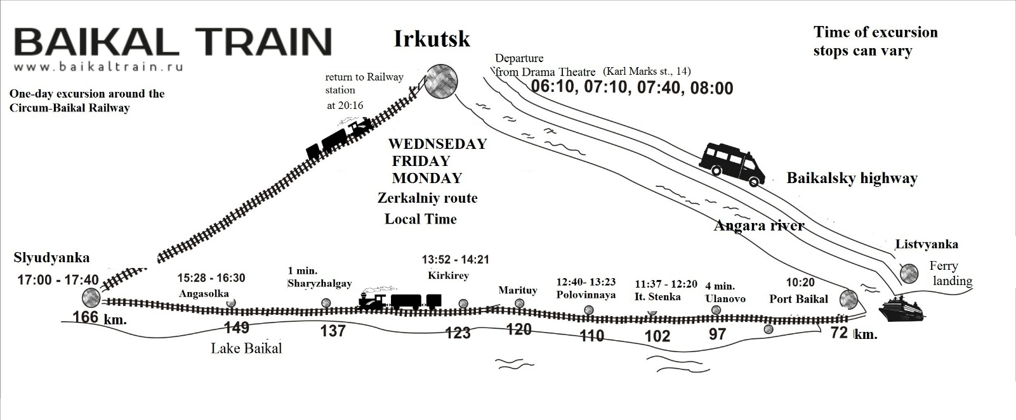

On Wednesdays, Fridays, and Mondays, the route begins next to the Okhlopkov Drama Theatre (14 Karla Marksa Street). The time of departure is indicated in the mirror route tickets. Next to the parking pocket opposite the central entrance to the theatre, the attendant will wait for you holding a name badge. Please prepare your tickets in advance for checking before boarding the bus. The boarding begins 15 minutes before departure. ATTENTION! You should board the bus strictly according to the time specified by your ticket. For example, if you have a departure time of 08:00 in your ticket, and you have come to the theatre by 07:30, you MUST NOT board the bus that departs at 07:40 (it goes to another pier). The bus then goes to Listvyanka. There will be no tour guide in the bus. You will then board a ship in Listvyanka. Please listen carefully to the instructions provided by your tour guide. Then you will enjoy a short voyage to the Port Baikal.
Port Baikal | 10:20
Ulanovo (97 km) | 11:21-11:25
Italyanskaya Stenka  (The Italian Wall) (102 km) | 11:37-12:20
Polovinnaya (110 km) | 12:40-13:23
Kirkirey (123 km) | 13:52-14:21
Angasolka (149 km) | 15:28-16:30
Slyudyanka (166 km) | 17:00-17:40
Irkutsk-Passazhirskiy | 20:16
Attention!!! For those who begin their tour in Listvyanka: time and place for boarding the ship that are indicated in your ticket may vary! Please make sure to call the dispatchers on the day before the tour to check the details:
+7 (3952) 280-966, +7 (3952) 280-965, +7 (3952) 65-71-17, +7 (3952) 65-28-15, mobile: +7 902 176 22 11, +7 950 064 59 10
If you have arrived with the first ferry, feel free to visit the Port Baikal museum of the Circum-Baikal Railway construction history that is located in the station building (the entrance to the museum is free), drink some coffee in the canteen, have a walk along the picturesque terrain, and take photos with an old locomotive on the background while waiting for your tour to begin.
At the Baikal station, the boarding begins 30 minutes before departure.
At 10:20, the train departs from the Baikal station in an easterly direction to the Circum-Baikal Railway.
First stop is Ulanovo (4 minutes). This is a technical stop. Please make sure you stay in your car.
Next tour stop is called Italyanskaya Stenka, or The Italian Wall (43 minutes). The stop time may be shorter. Please listen carefully to your guide.
Next stop is Polovinnaya station (43 minutes). This is a free time stop; there will be no guided walks here. The stop time may be longer. Please listen carefully to your guide.
At this stop, meals are served for those who have ordered the Homemade Lunch (Domashny Obed) service. Make sure to ask your tour guide at the beginning of the journey where you will eat. There are two options: 1) we will accompany you to the veranda, where the lunch is served; or 2) we will bring the lunch to your car.
There is a small settlement called Polovinny in the area and Polovinnaya River flows there as well – it is the largest river in the western part of the Circum-Baikal Railway. It is 43 km long. Above the river, there are two bridges:
- A metal bridge built during the first stage of the railway construction with train ways down and the 6 m wide opening. Its weight is 203.2 tons.
- A reinforced concrete viaduct of arch type built during the second stage of the railway construction with three openings of 20 m each. It is 84 m long.
Before the bridges, you will see an old E Series steam locomotive. Locomotives of that type used to be delivered to Russia from the US in 1943-1944 under the Land Lease Supply Program during the World War II. The locomotives were also called Amerikanka trains. The capacity of the locomotive is 1,920 hp, speed – 70 km/h, length – 21 m, and weight – 103 tons.
There also is a very convenient descent to Baikal to a cozy shallow-water bay, located between the Polovinny Cape and the small but very steep Chaykin Cliff.
There, too, is the longest tunnel of the Circum-Baikal Railway, the tunnel No. 12, or Polovinny Tunnel. Its length is 778 m. Besides, this tunnel is completely straight; if you stand at one end of it, you will see the light coming from the other end. In the same area, you can find the shortest tunnel (32 m), which, according to legend, makes the most cherished wishes come true.
Next tour stop is Kirkirey (29 minutes). You can go out from cars No. 1, No. 2, No. 3, No. 4 only. Therefore, for those who travel in cars Nos. 5, 6 and 7, it is necessary to proceed to the said cars to join a guided walk. Please be careful! Please make sure to not walk too far away from the train. Listen carefully to the locomotive signals – the train leaves after the third signal.
Next tour stop is Angasolka (1 hour). As you get out of the train please walk in the opposite direction, to the tail of the train. The guide will wait for you there to begin the guided walk.
This is the last sightseeing stop on the Circum-Baikal Railway. Then the train leaves for Slyudyanka.
In Slyudyanka, a stop lasts 40 minutes. You can get out of your car and have a look at the beautiful station building – the only railway station in the world that is completely built of white and pink marble.
At 17:40, the train departs from Slyudyanka to Irkutsk in a western direction. There will be no stops except for a one-minute stop at the Goncharovo station (Shelekhov) at 19:52.
The train will then arrive at Irkutsk-Passazhirskiy at 20:16.
Please do not leave your belongings in the car unattended.

